 | Bansilal Ramnath Agarwal Charitable Trust’s Vishwakarma Institute of Information Technology  Department of  Artificial Intelligence and Data Science
Student Name: Sathe Onkar Abasaheb
Class: TY | Division: B |  | Roll No: 372078
Semester: V |  | Academic Year: 2025-2026
Subject Name & Code: Cloud and DevOps
Assignment No: 07
Title of Assignment: Configuration Management with Ansible – Write a playbook to deploy a web server.

Date of Performance: / /2025 |  | Date of Submission: / /2025

Title:Deployment of a Web Server using Ansible Configuration Management.

2. Objective
- Automate the installation and configuration of a web server using Ansible.
- Write a YAML-based playbook to install and configure Nginx or Apache.
- Deploy a sample webpage automatically to demonstrate idempotency and automation.
- Understand the working of inventory files, variables, templates, and handlers in Ansible.
- Verify the deployment by accessing the web server from a browser.

3. Tools & Technologies
- Ansible (Automation and Configuration Management Tool)
- Python 3 (for Ansible runtime)
- Nginx / Apache2 (Web server)
- Linux Environment / Ubuntu Server / CentOS / RHEL
- SSH (for connecting to target nodes)
- YAML & Jinja2 Templates

4. Prerequisites
- Control node with Ansible installed (sudo apt install ansible -y).
- Target node accessible via SSH and configured in the Ansible inventory file.
- Internet access for package installation (or local repository configured).
- Proper directory structure for Ansible project:

Directory Structure:

├── inventory/hosts
├── playbooks/deploy-web.yml
├── templates/index.html.j2
└── group_vars/webservers.yml

5. Step-by-Step Procedure:

Step 1: Check Ansible Installation
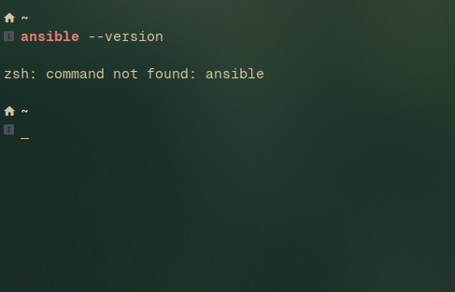
Step2: Installing ansible from Arch user repository:
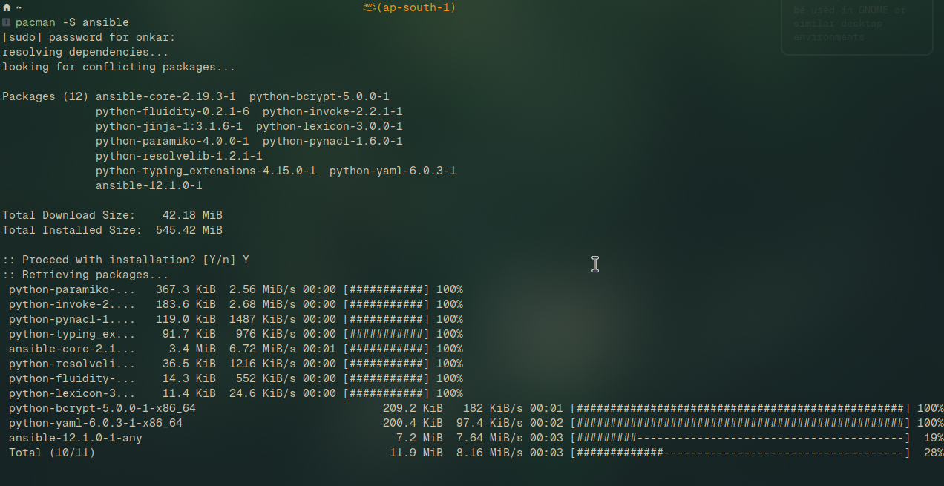
--

Step 3: Defining Configuration:
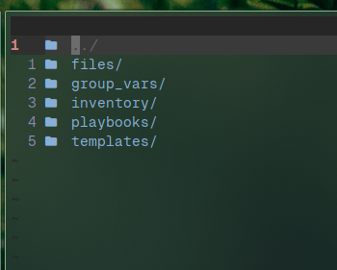
Step 4: Defining web server file.
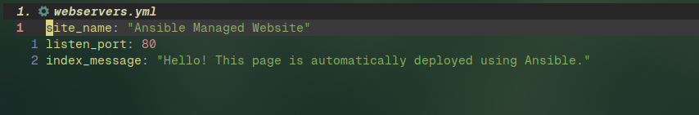
Step 5: Defining host:

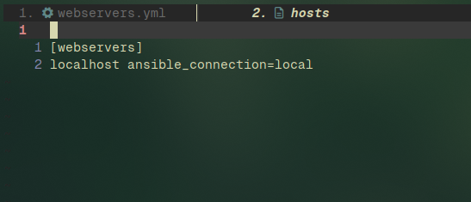

Step 5: Defining an ansible config :

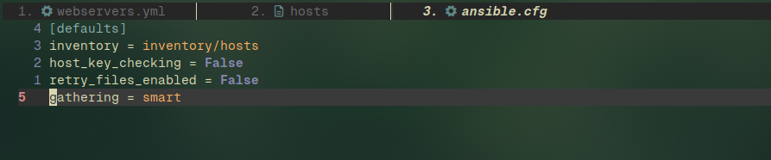
Step 6:Definging Deployment .yml:
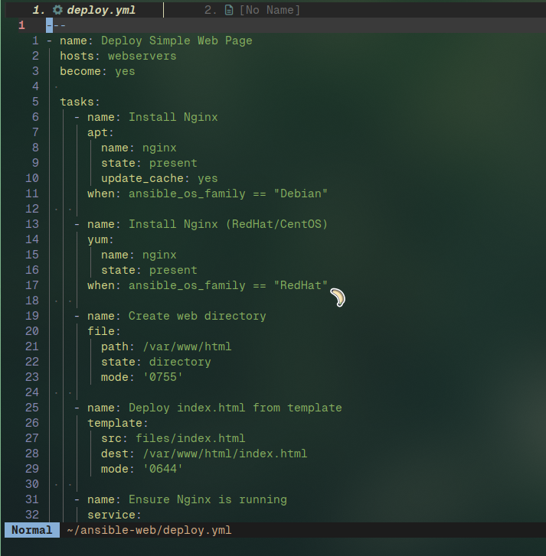
Step 7: Run ansible Playbook:
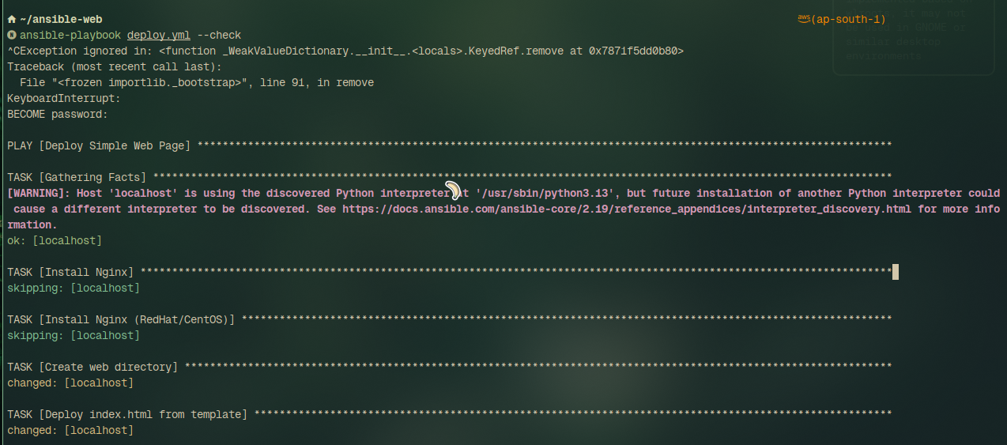
Step 8: Run an Node.js application:
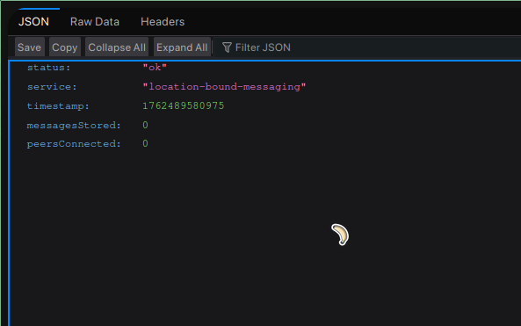
- Conclusion:
This assignment demonstrated how Ansible automates configuration management by defining system states declaratively.
The playbook installed Nginx, deployed a custom web page, and ensured the service was up — all without manual intervention.
Re-execution confirmed idempotency, proving Ansible’s reliability for repeatable deployments.
Such automation simplifies large-scale server management, reduces configuration drift, and forms the backbone of DevOps pipelines.

